**LAB 1 – Part 1**

Create this simple synthesizer below using the file “Lab1 - Part 1-DEMO.maxpat”

**Due: turn in a screen shot of your finished patch and name it as “lastname firstname lab 1 part 1”**

Follow the class demonstration and the extensive comments within the patch to guide you to make this patch pictured below.

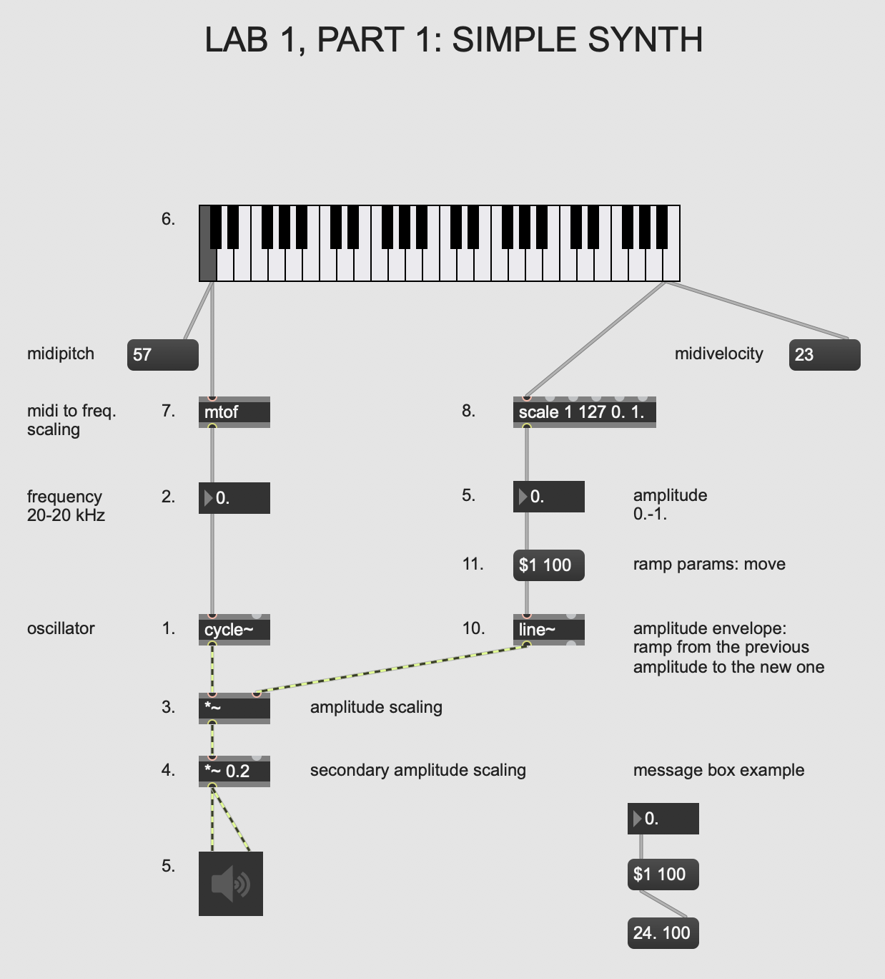

**LAB 1 – Part 2**

Create this simple synthesizer below using the file “Lab1 - Part 2-DEMO.maxpat”

**Due: turn in a screen shot of your finished patch and name it as follows: “lastname firstname lab 1 part 2”**

Follow the class demonstration and the extensive comments within the patch to guide you to make this patch pictured below.

Then, follow the instructions in Lab 1, Part 3 **BEFORE** closing this patch.

\

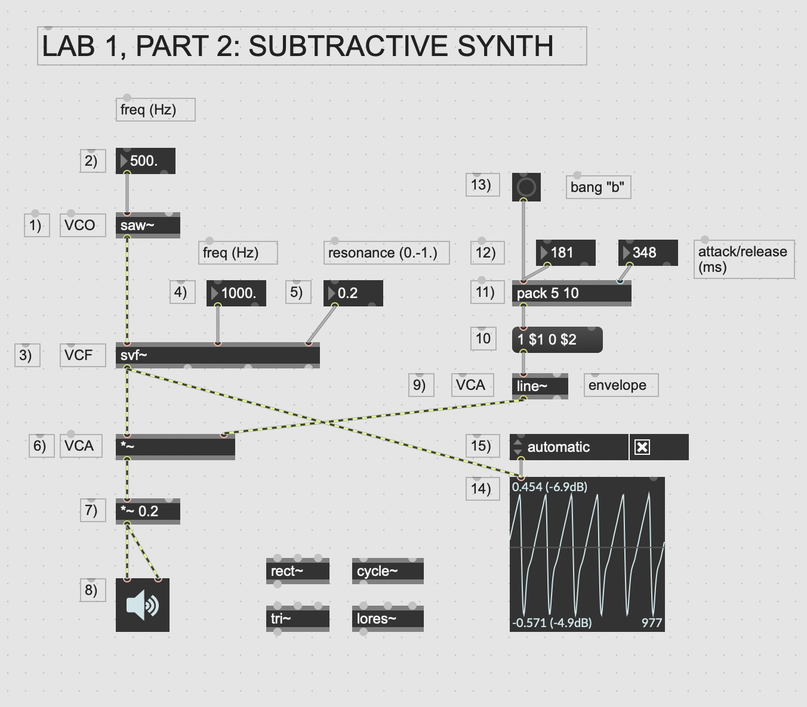

**LAB 1 – Part 3**

**Due: Answer the questions below and turn in the answers in a document labeled as follows: “lastname firstname lab 1 part 2”**

1. Explore your subtractive synth by trying out different values for the parameters of: VCO (frequency in Hz.),

VCF (frequency in Hz.)

VCF resonance (0.-1. range of values)

and envelope parameters for attack (ms.)

and release (ms.) times

**Provide one set of values for all of these parameters above that is appropriate to make sound and sounds good to you.**

**Answer:** any values that fall in these ranges:

VCO frequency should be in the audio range (20Hz-20kHz), but the most useable range is from 50Hz to around 1000Hz. VCF frequency should be higher than the VCO frequency, and will likely be in the range of 1x to 10x the VCO frequency. VCF resonance should be between 0 and 1 - between 0.9 and 0.98 will be the most musically interesting values. Attack and decay times are in milliseconds- attack generally between 5ms and 100ms, and decay between 100ms and 1000ms.

2. **If the time of the attack is set to 0 seconds how does it sound? Why do you think this is?**

**Answer: any response that touches on some of the points below**

Remember that the VCO is always generating sound. The VCA is like an automatic volume control controlled by the envelope. With an attack time of 0 ms, the volume jumps from nothing to full volume instantanously creating a sharp edge in thewaveform. This edge sounds like a click when we listen to it. By using an attack time of 5 ms or greater, we smooth out the sharp edge so we don't hear the click.

3. Change out the VCO with the cycle~, tri~ and rect~. **How would you characterize the sound of the saw~ as VCO compared with the cycle~ as VCO? Why do you think that the saw waveform is more appropriate for subtractive synthesis than a sinewave?**

**ANSWER: anything that touches on these ideas**

The sawtooth wave will sound buzzier than the other waveforms. People often describe the square wave as sounding hollow, but it is nearly as bright as the sawtooth. The triangle wave will sound much more mellow and the sine wave will sound very purer with only a single frequency component. A sawtooth wave works better for subtractive synthesis because the filter will interact with the harmonics to change the sound drastically. Since a sine wave only has a single frequency component, changing the filter frequency will only have an effect when the filter is the same frequency as the VCO, and it is not nearly as dramatic as with a sawtooth wave.

4.Alter the filter resonance to test values around 0.0, 0.5, and 0.9. Also, change the filter frequency at each resonance value. **Describe how the**

**the filter resonance affects the sound**.

**ANSWER: accept any subjective description from the student here.**

With values from 0 to 0.9 there will be a mild change in the sound as the filters cut off frequency is accentuated.

5. Before doing this question, be sure that you are using a rich signal, like the a saw~ object as your VCO.

The leftmost outlet of our voltage controlled filter, the svf~ object, is a lowpass filter. Set your filter frequency to 900 and your VCO frequency to something around 660 Hz and listen.

Now disconnect the first outlet from your leftmost outlet of the svf~ . Then patch a new connection from the second outlet of your svf~ into the *~ below it. This is makes the svf~ act as a highpass filter.

**How do the lowpass and highpass filters sound compared with one another? Why do you think that they sound different?**

**ANSWER:**

**Accept any subjective student answer that suggests that the low pass filter is darker and the high pass filter makes the sound comparatively brighter.**

The low pass filter will would remove the higher harmonics so the sound will sound darker. The high cost filter will attenuate the fundamental frequency, while leaving the higher harmonics unaffected. This may make the sound thinner. They sound different because he low pass filter attenuates harmonics above the filter cut off while the high pass filter attenuates frequencies below the filter cutoff.